[](https://avatanplus.com/files/resources/original/5af04c014dec21633aa8e527.png)

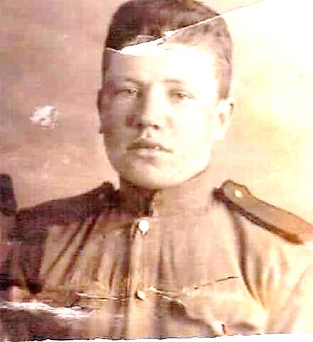

**КАРПОВ**

**АЛЕКСАНДР НИКОЛАЕВИЧ 1924 г.**

